Smart Chassis Vibration Analysis System
Project Report — Module 4

1. Abstract
The chassis is one of the main supporting structures of a vehicle and experiences different loads and vibrations while the vehicle is in motion. Continuous or abnormal vibration may indicate structural problems such as cracks or loose joints.
This project presents a Smart Chassis Vibration Analysis System designed to detect and analyze vibrations in a vehicle chassis. Accelerometers are positioned at important points on the chassis to collect real-time vibration data. The collected data is processed to identify abnormal frequency patterns that may indicate potential structural damage.
When the detected vibration exceeds a predefined threshold, a warning telltale such as an LED or dashboard symbol can alert the driver. The proposed system demonstrates how vibration monitoring can contribute to vehicle safety and early identification of possible structural issues.

2. Introduction
The chassis is the main support frame of a vehicle. During vehicle operation, the chassis experiences varying loads and vibrations caused by road conditions, vehicle motion and other operating conditions.
Monitoring chassis vibration can provide useful information about the structural condition of the vehicle. A vibration sensor such as an accelerometer can be placed at selected points on the chassis to collect vibration data continuously.
The collected data can then be processed to identify abnormal vibration patterns. If the vibration exceeds a specified threshold, the system can provide a warning to the driver through a telltale indicator.

3. Problem Statement
A vehicle chassis is continuously subjected to mechanical loads and vibrations. Abnormal vibration patterns may indicate possible structural problems such as cracks or loose joints.
The problem addressed by this project is to design a system capable of monitoring chassis vibration, identifying abnormal vibration patterns and providing a warning indication when the vibration exceeds a specified threshold.

4. Objectives
- To monitor vibration in the vehicle chassis.
- To collect real-time vibration data using accelerometers.
- To analyze vibration patterns at important chassis locations.
- To identify abnormal frequency patterns.
- To detect vibration conditions that may indicate structural problems.
- To provide a warning telltale when vibration exceeds the defined threshold.
- To improve vehicle structural safety through vibration monitoring.

5. Concept of the System
The proposed system is based on the principle that the vehicle chassis experiences different levels and patterns of vibration during operation.
Accelerometers are installed at selected points on the chassis. These sensors continuously measure vibration-related motion and provide data to a processing unit.
The processing system analyzes the collected vibration information and identifies abnormal frequency patterns. Such abnormal patterns may indicate potential structural problems such as cracks or loose joints.
When the measured vibration exceeds the defined threshold, the system activates a warning telltale.

6. System Components

6.1 Chassis
The chassis acts as the primary structural component being monitored. It experiences different loads and vibrations during vehicle operation.

6.2 Accelerometers
Accelerometers are used to measure vibration at selected points on the chassis. They provide real-time vibration information to the processing system.

6.3 Microcontroller
The microcontroller receives the sensor data and performs the required processing to identify abnormal vibration patterns.

6.4 Warning Telltale
A warning telltale provides an indication to the driver when the vibration exceeds the defined threshold. The telltale can be implemented using an LED or a dashboard warning symbol.

7. System Architecture
The proposed system can be represented as shown below.
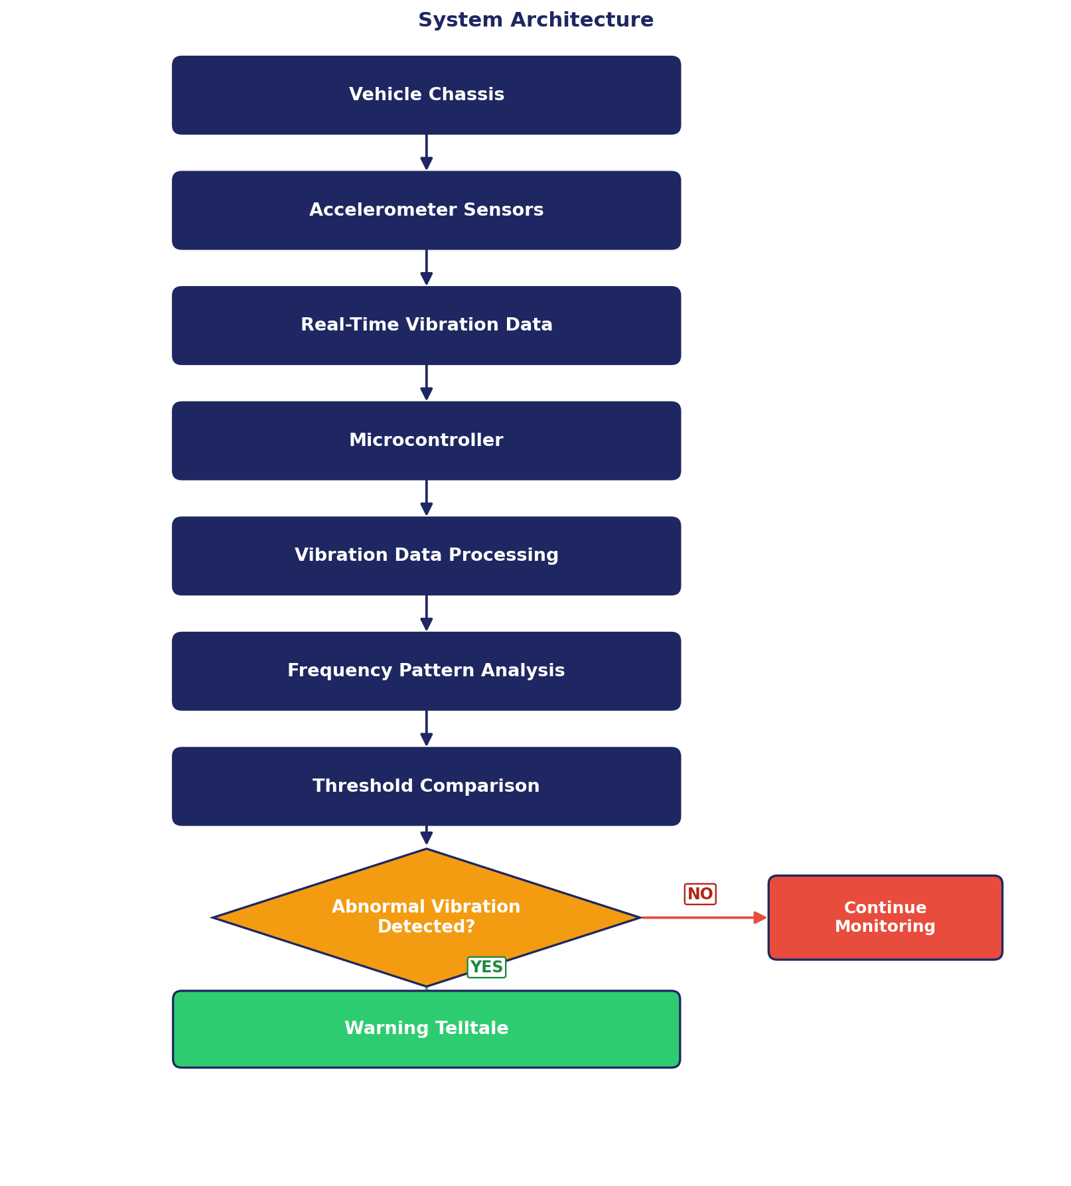
Figure 1. System architecture with threshold-based decision logic.

8. Working Principle
The working process of the Smart Chassis Vibration Analysis System consists of the following steps.

Step 1: Sensor Placement
Accelerometers are placed at important points on the vehicle chassis.

Step 2: Vibration Measurement
During vehicle operation, the accelerometers continuously collect vibration information.

Step 3: Data Transmission
The sensor measurements are transmitted to the microcontroller or processing unit.

Step 4: Data Processing
The microcontroller processes the incoming vibration data.

Step 5: Frequency Analysis
The system analyzes the vibration data to identify abnormal frequency patterns.

Step 6: Threshold Comparison
The detected vibration level is compared with a predefined threshold.

Step 7: Warning Generation
If the vibration exceeds the threshold, the warning telltale is activated.

Step 8: Continuous Monitoring
If the vibration remains within the acceptable range, the system continues monitoring the chassis.

9. Data Flow
The overall data flow is shown below.
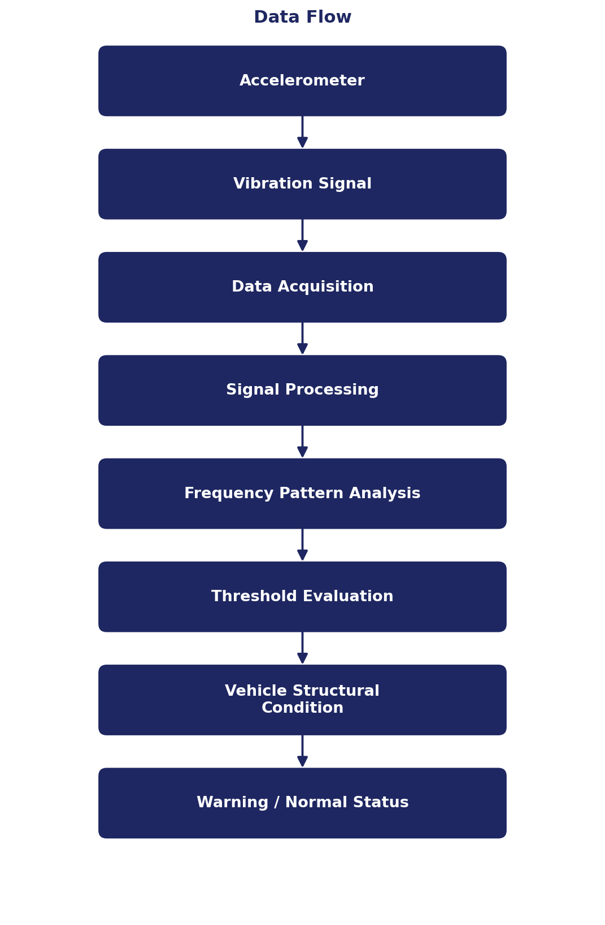
Figure 2. Overall vibration monitoring data flow.

10. Vibration Analysis
Vibration data collected from the chassis can be analyzed to identify changes in vibration behavior.
Normal vehicle operation produces vibration patterns within an expected range. An abnormal vibration pattern may indicate a potential structural issue.
The analysis therefore focuses on identifying changes or abnormal frequency patterns in the measured vibration data.

11. Threshold-Based Warning System
The warning system uses a predefined vibration threshold.
Threshold Rule
Measured Vibration ≤ Threshold: → continue normal monitoring
Measured Vibration > Threshold: → activate warning telltale

The threshold is used to distinguish between acceptable vibration and vibration requiring attention.

12. Warning Telltale
The warning telltale provides a visual indication to the driver. Possible implementations include an LED indicator or a dashboard warning symbol. A simplified status system can be represented as:
Condition | System Status | Telltale
Vibration within acceptable range | Normal | OFF
Vibration approaching threshold | Monitoring | OFF
Vibration exceeds threshold | Warning | ON

13. Example Operating Scenario
Consider a vehicle travelling over a road surface. The accelerometers continuously measure the vibration experienced by the chassis. Under normal conditions, the vibration remains within the acceptable operating range.
If an abnormal vibration pattern develops, the system identifies the change through vibration analysis.
If the measured vibration exceeds the defined threshold, the microcontroller activates the warning telltale.
The driver is therefore informed that the vehicle chassis requires further inspection.

14. Related Safety Application
The system is related to vehicle structural safety because abnormal chassis vibration may indicate potential structural problems.
The warning telltale provides an early indication that allows the driver or maintenance personnel to investigate the vehicle condition.
The system is therefore intended as a monitoring and warning mechanism rather than a replacement for detailed physical inspection.

15. Advantages
- Continuous chassis vibration monitoring.
- Real-time sensor-based data collection.
- Early identification of abnormal vibration patterns.
- Warning indication for excessive vibration.
- Potential detection of conditions associated with cracks or loose joints.
- Improved awareness of vehicle structural condition.
- Can be integrated with a vehicle dashboard warning system.

16. Limitations
- Sensor placement affects the quality of collected vibration data.
- Incorrect threshold selection can result in false warnings or missed conditions.
- Vibration can be influenced by road conditions and normal vehicle operation.
- Vibration data alone may not conclusively identify a specific structural defect.
- Physical inspection may still be required to confirm structural damage.

17. Future Scope
- Installing multiple accelerometers at different chassis locations.
- Developing a real-time vibration monitoring dashboard.
- Recording historical vibration data.
- Applying advanced signal-processing techniques.
- Using machine-learning techniques to identify abnormal vibration patterns.
- Integrating the system with vehicle diagnostic systems.
- Adding automated fault classification.
- Connecting the warning system with the vehicle's electronic dashboard.
- Developing predictive structural-health monitoring capabilities.

18. Expected Outcome
The expected outcome of the project is a model demonstrating how vibration data can be used to monitor the structural condition of a vehicle chassis.
The system collects vibration information through accelerometers, processes the data using a microcontroller and identifies abnormal frequency patterns.
When the vibration exceeds the defined threshold, a warning telltale alerts the driver.
The overall objective is to use vibration monitoring as a means of identifying potential structural issues and enhancing vehicle safety.

19. Conclusion
The Smart Chassis Vibration Analysis System provides a concept for monitoring vehicle chassis vibration and identifying abnormal vibration conditions.
By placing accelerometers at important chassis locations, real-time vibration data can be collected and processed. Abnormal frequency patterns can then be identified and compared against a predefined threshold.
When excessive vibration is detected, a warning telltale can alert the driver. This approach demonstrates how sensor-based monitoring can contribute to vehicle structural safety and provide an early indication of potential issues such as cracks or loose joints.
The proposed system can be further developed using advanced signal processing, machine learning and vehicle diagnostic integration to create a more comprehensive structural health monitoring system.

20. References
1. Module 4 Project Assignment — Smart Chassis Vibration Analysis System.
2. Chassis vibration monitoring concepts.
3. Accelerometer-based vibration measurement concepts.
4. Vehicle structural safety and monitoring concepts.

